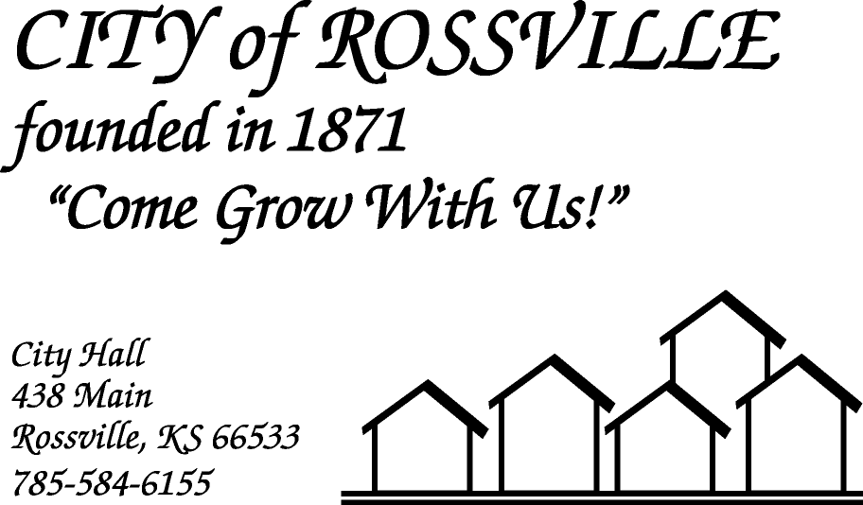

**AGENDA**

**MONDAY**

**JUNE 1, 2020**

***AGENDA SUBJECT TO CHANGE***

7:00pm MINUTES

BILLS

ADOPT AGENDA

7:05 pm BILL RIPHAHN-SN CO COMMISSIONER

Swimming Pool

Drainage Ditch

7:25 pm COUNCIL REPORT

ISO Ratings Report

7:35 pm UTILITY DEPT REPORT/BUSINESS

7:45 pm POLICE DEPT REPORT/BUSINESS

7:55 pm OLD BUSINESS

Stimulus Infrastructure Priority List

Rossville Community Recreation Assoc-Summer Ball Program

Dog Tag Late Fees

Re-opening of Playground

Re-opening of Campbell Field

Re-opening of City Hall

8:20 pm NEW BUSINESS

8:30 pm ADJOURN

**NOTE: As City Hall is Closed to the public due to COVID-19 the meeting will be online using ZOOM meeting service**

**Meeting ID: 872 3495 7107**

**Password: 925699**

**Please call City Hall at 785 584-6155 if you need assistance.**